E-mail: sdfasiullah924@gmail.com

Contact: 7097450534

**SportyShoes.com**

**RESTful Spring Boot E-Commerce portal with JPA Data Base & Front-End with Angular v8:**

In this project, I developed Restful Spring Boot E-Commerce portal named SportyShoes.com that uses internal memory database i.e., Spring H2 Data Base to store all the information about the products, users who purchased it & this information can be fetched up by date & Customer name as well.

I developed the Front end of this using Angular as a JavaScript Frame Work.

Here, Admin can manage all the products by categorizing them as brand, color, size & price.

Admin can see the purchase list filtered by date & category.

**Tools:**

1. Agile-Scrum-Jira
2. Spring Tool Suite | 4
3. Spring boot initializer
4. Angular version 8.3.19
5. Postman
6. Git
7. GitHub

**Steps for Execution:**

1. Clone the project from the repository

GitHub Link: ***https://github.com/SyedFasiHussaini/Phase3Project.git***

As I have developed the RESTful API, it can be run on postman tool.

1. I have used SWAGGER in my spring boot RESTful API project so that the project documentation can be well understood and can easily be verified.
2. URL for the SWAGGER documentation:

[**https://localhost:9200/swagger-ui.html**](https://localhost:9200/swagger-ui.html)

1. All the endpoints and example data will be present in that link and an option to try it out, Put the data into which will be in JSON format and simply try it out.

**Headers End-Point**

1. **Get/Post/Put to get, add & update all Shoes---------------- /shoes**
2. **Get Shoes by Category:**
3. **Get shoes by brand ----------------------- /shoes/brand/{brand}**
4. **Get shoes by color ------------------------ /shoes/color/{color}**
5. **Get shoes by size -------------------------- /shoes/size/{size}**
6. **Get shoes by price ------------------------ /shoes/price/{price}**
7. **Get/Delete shoes by Id---------------------------- /shoes/{id}**
8. **Post/Put to add & update user---------------------- /user**
9. **Get to get all users info. --------------------------- /users**
10. **Get Users by:**
11. **Get users by userId ------------------------- /user/{userId}**
12. **Get users by username-------------------- /user/username/{userName}**
13. **Get users by userAge ---------------------- /user/userAge/{userAge}**
14. **Get/Delete users by id ------------------------------ /user/{userId}**

**Screen Shots of the output result:**

1. **Database Storing all the different versions of products**

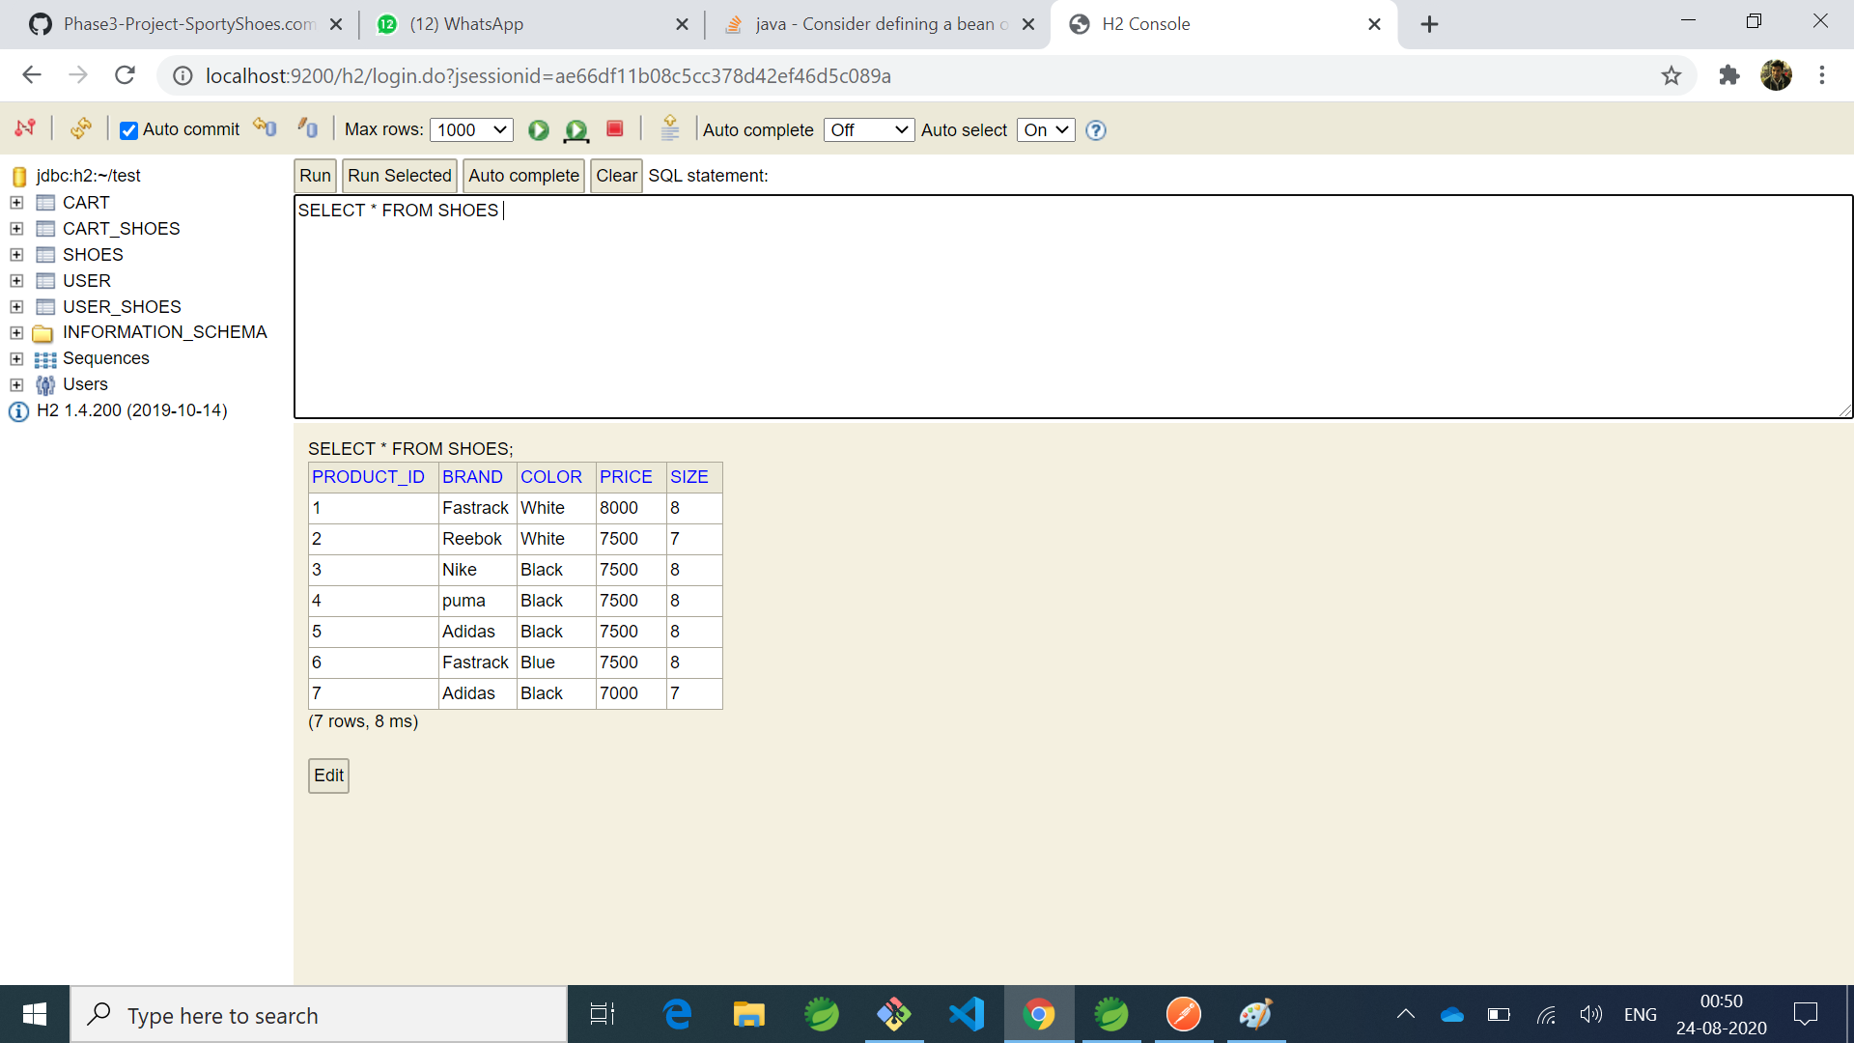

1. **Get method that fetches all the product details shown above in h2 DB in JSON format**

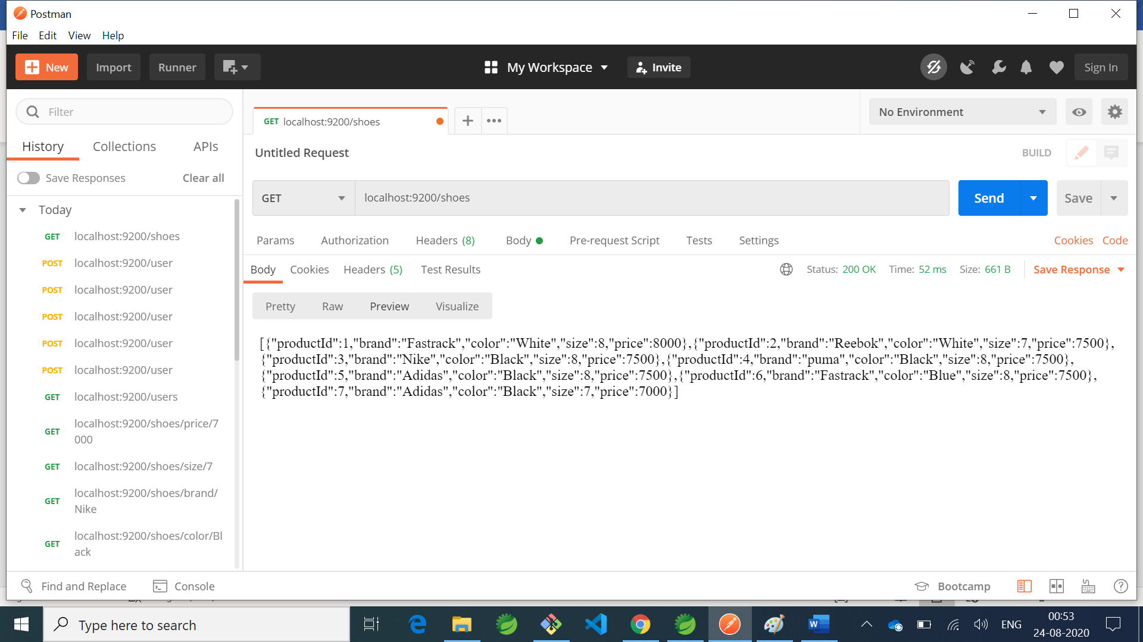

1. **Get method that fetches all the products by brand**

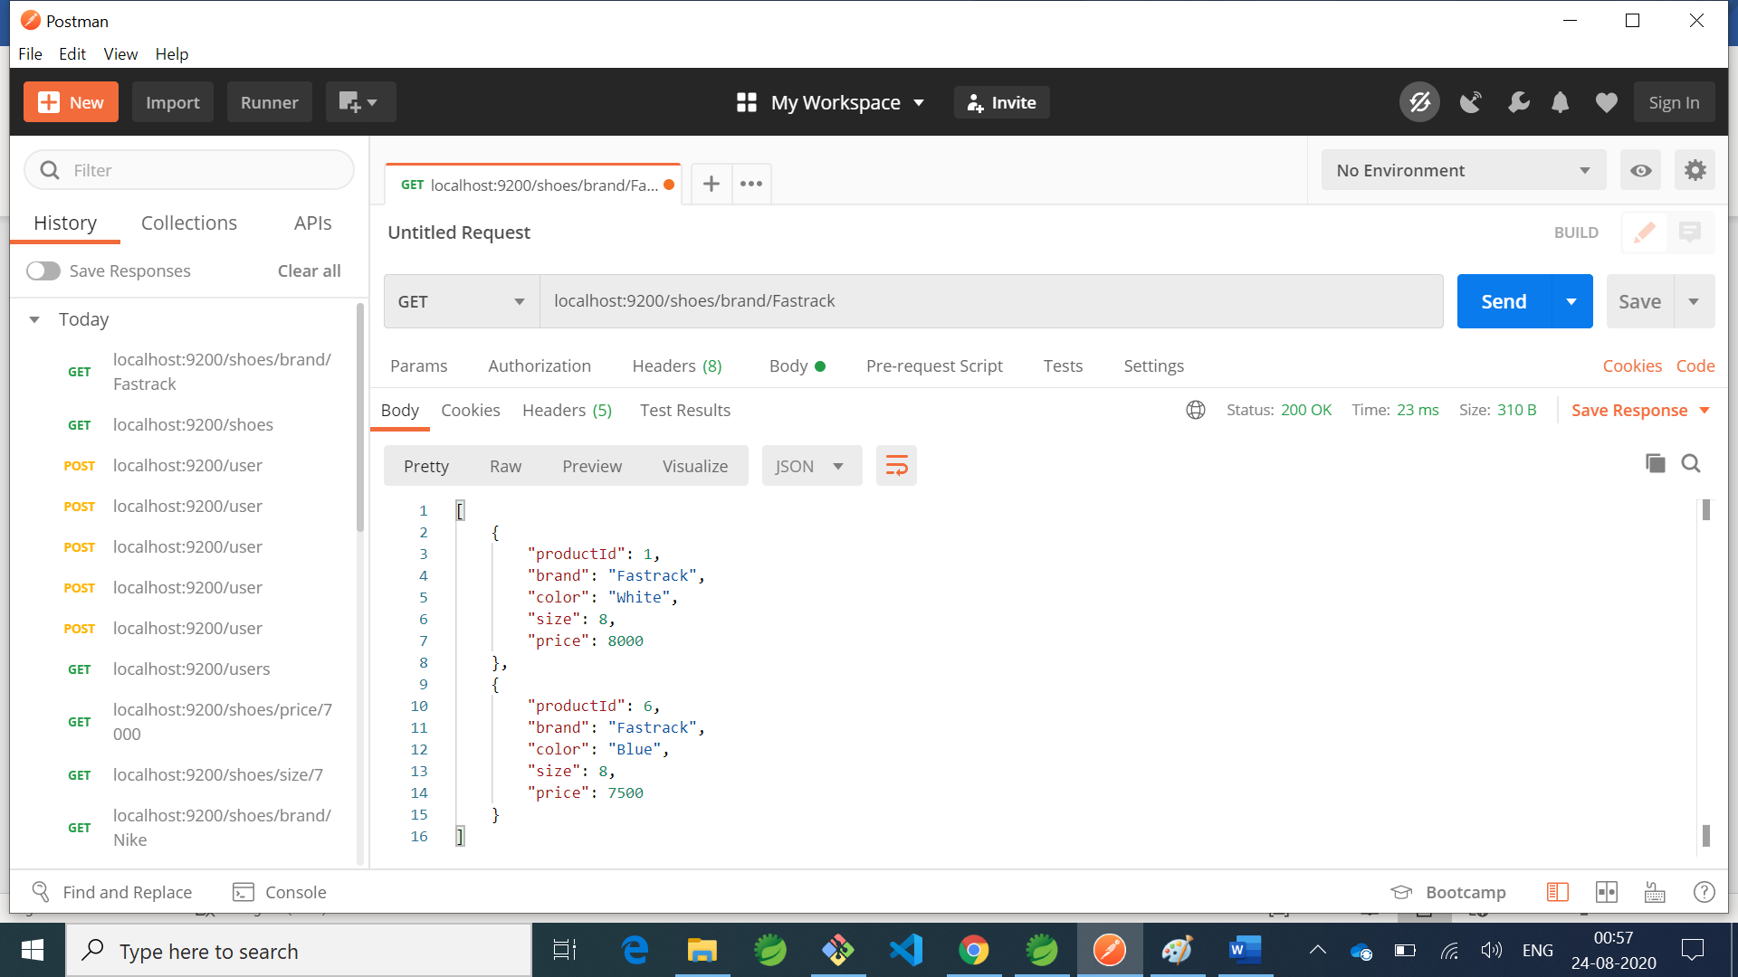

1. **Get Method that fetches based on price:**

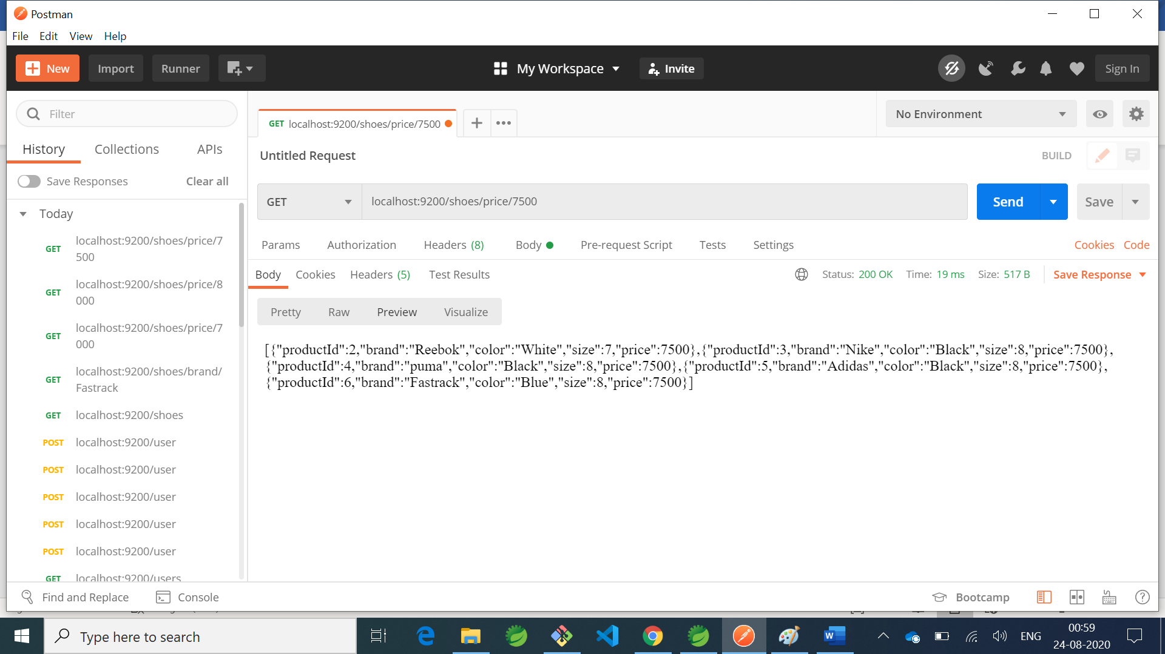

1. **Get Method that fetches based on color:**

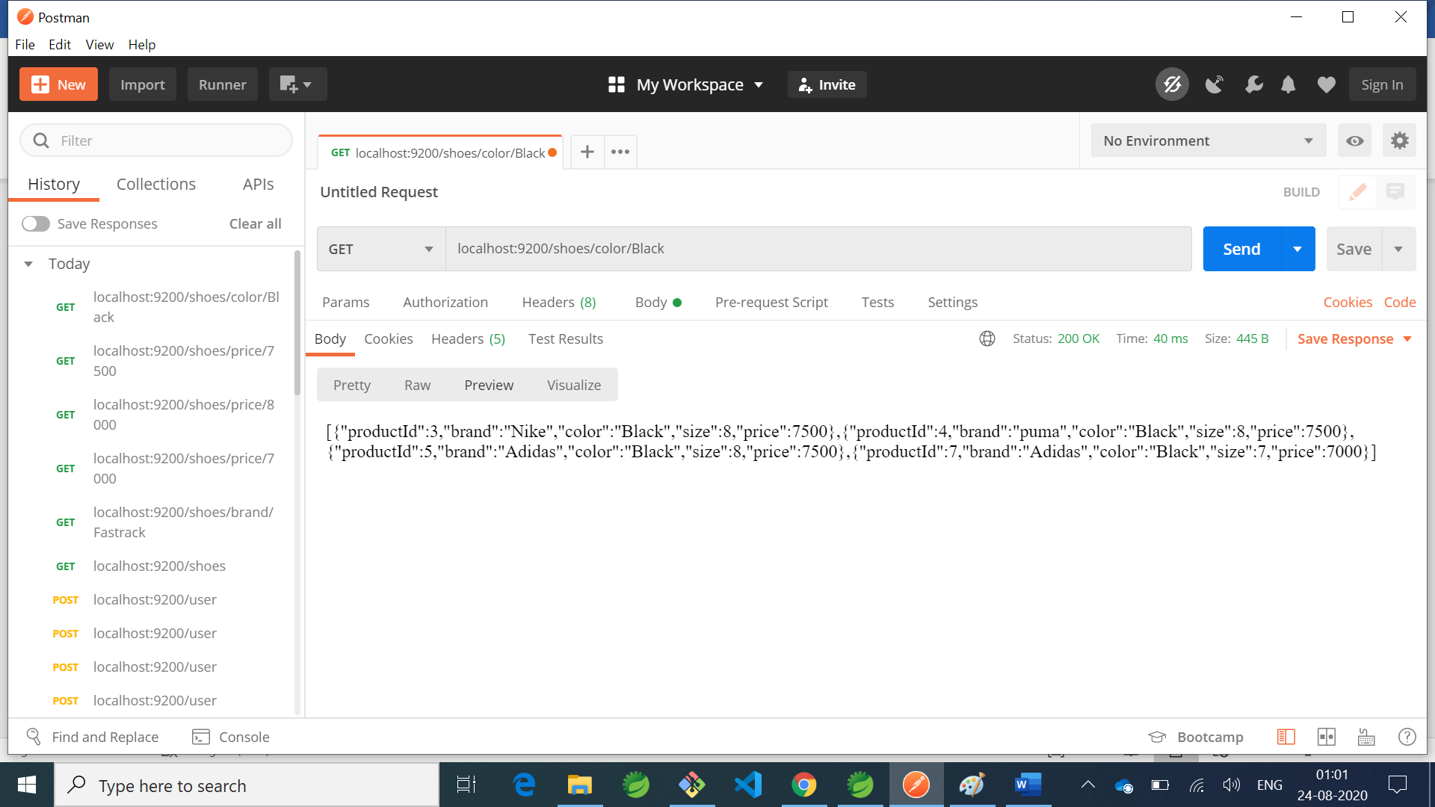

1. **User and Shoes detail added to h2 DB**

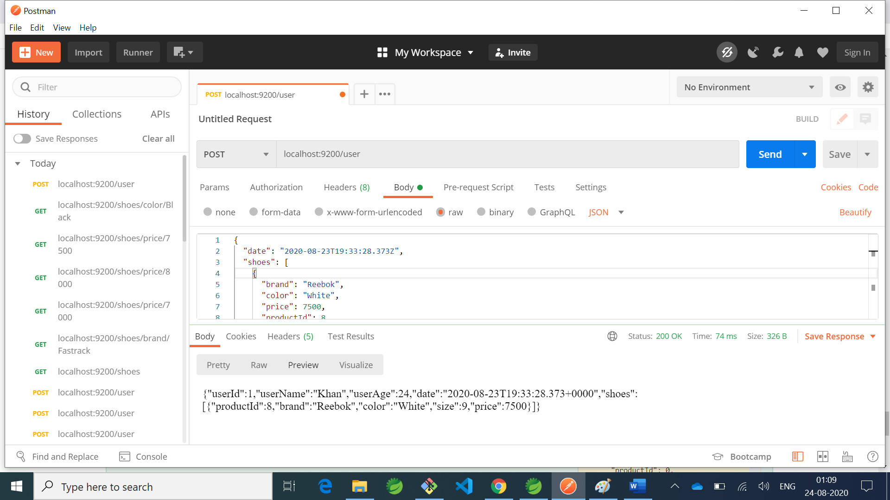

1. **User and product details fetched:**

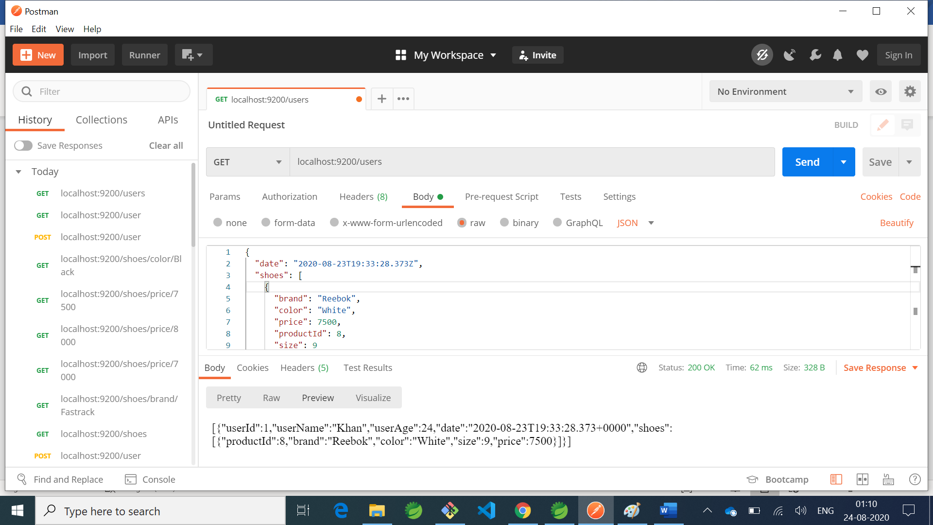

1. **Documentation that shows status 200 ok for delete method**

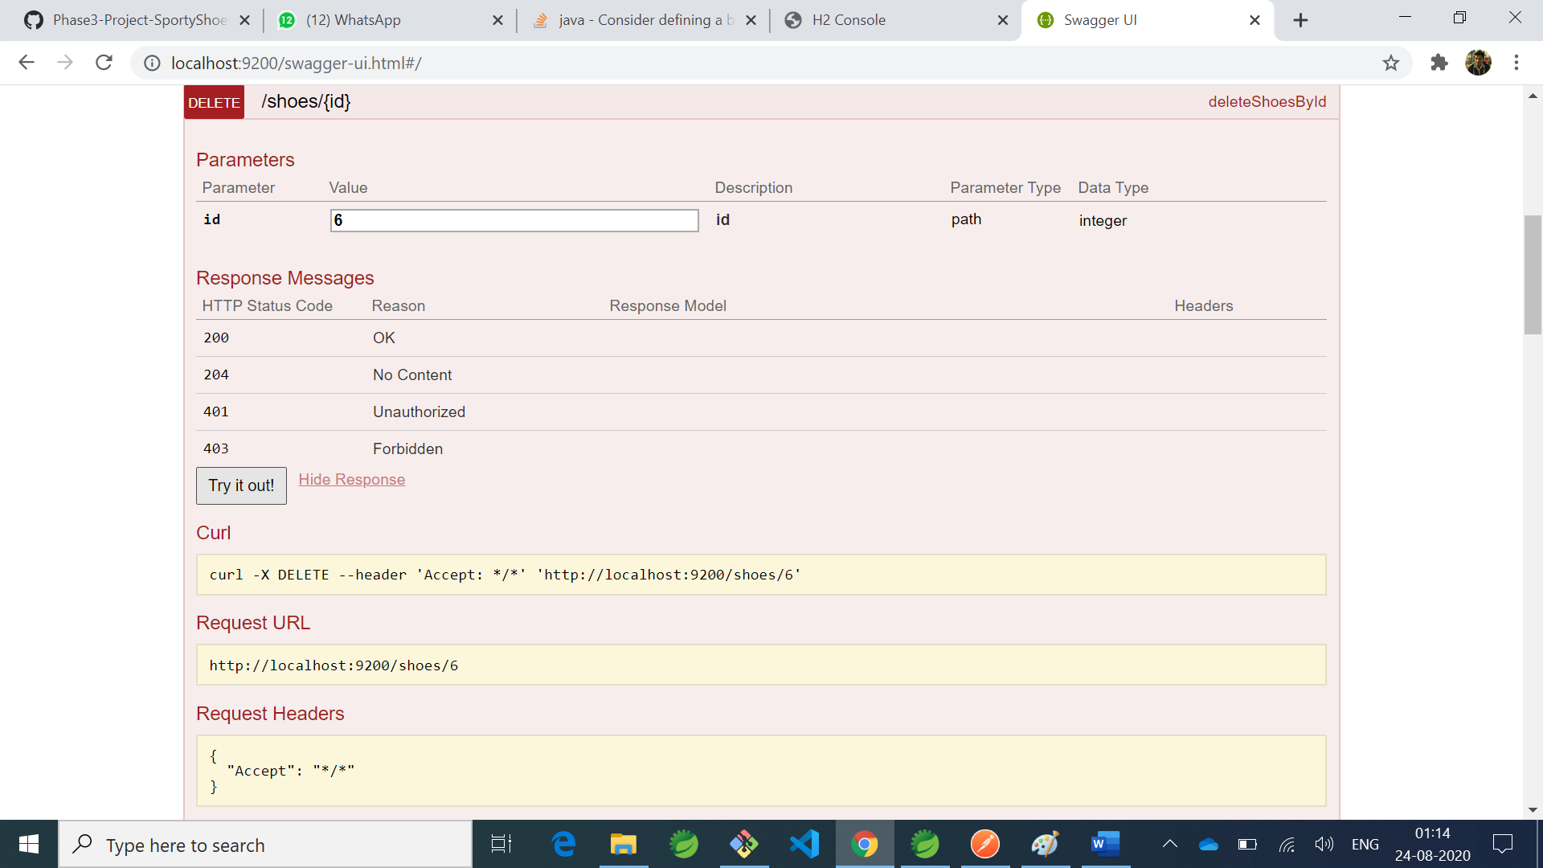

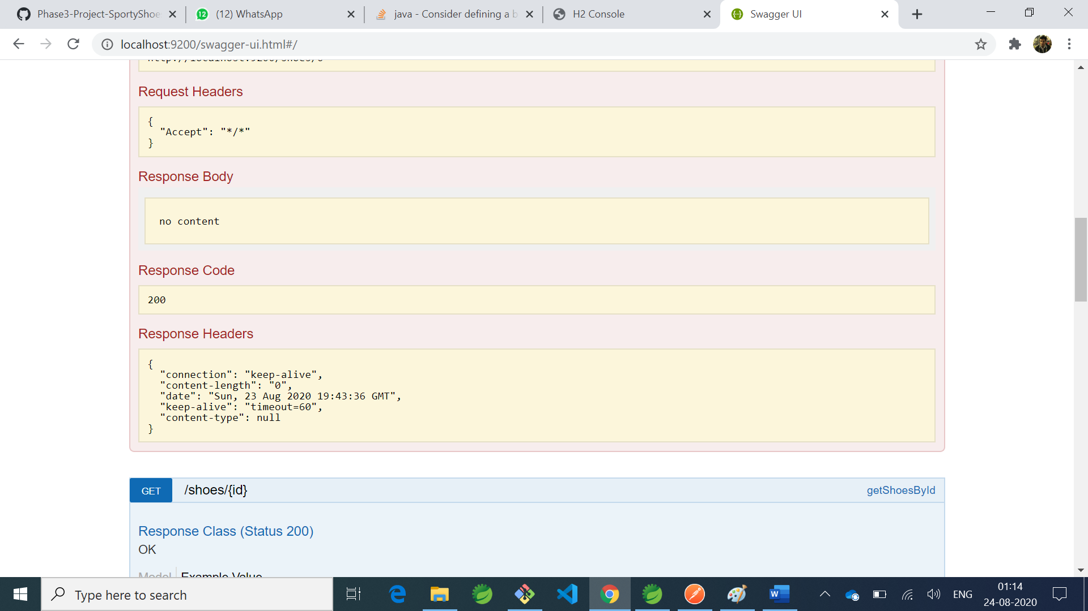

**UI of the above Application with Angular v8**

**1.View All Shoes i)**

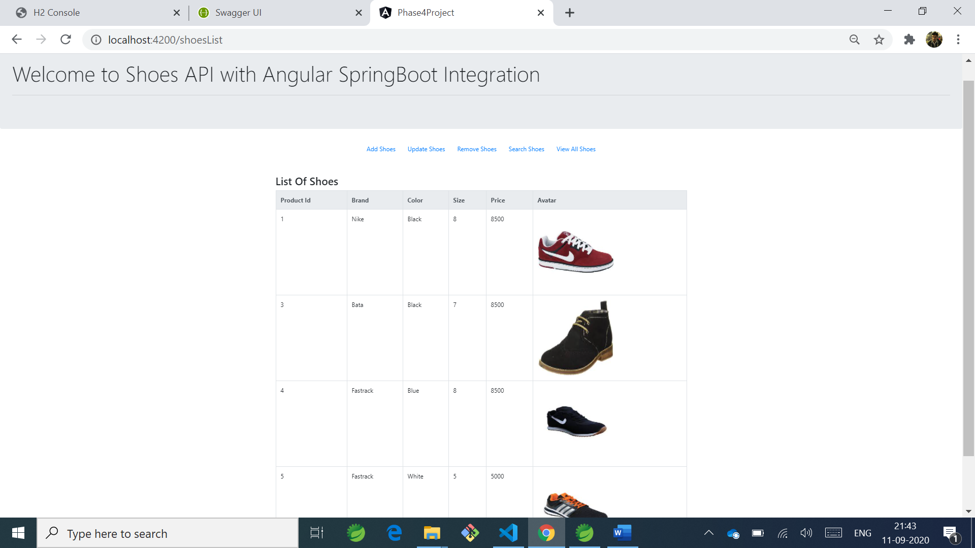

**ii)**

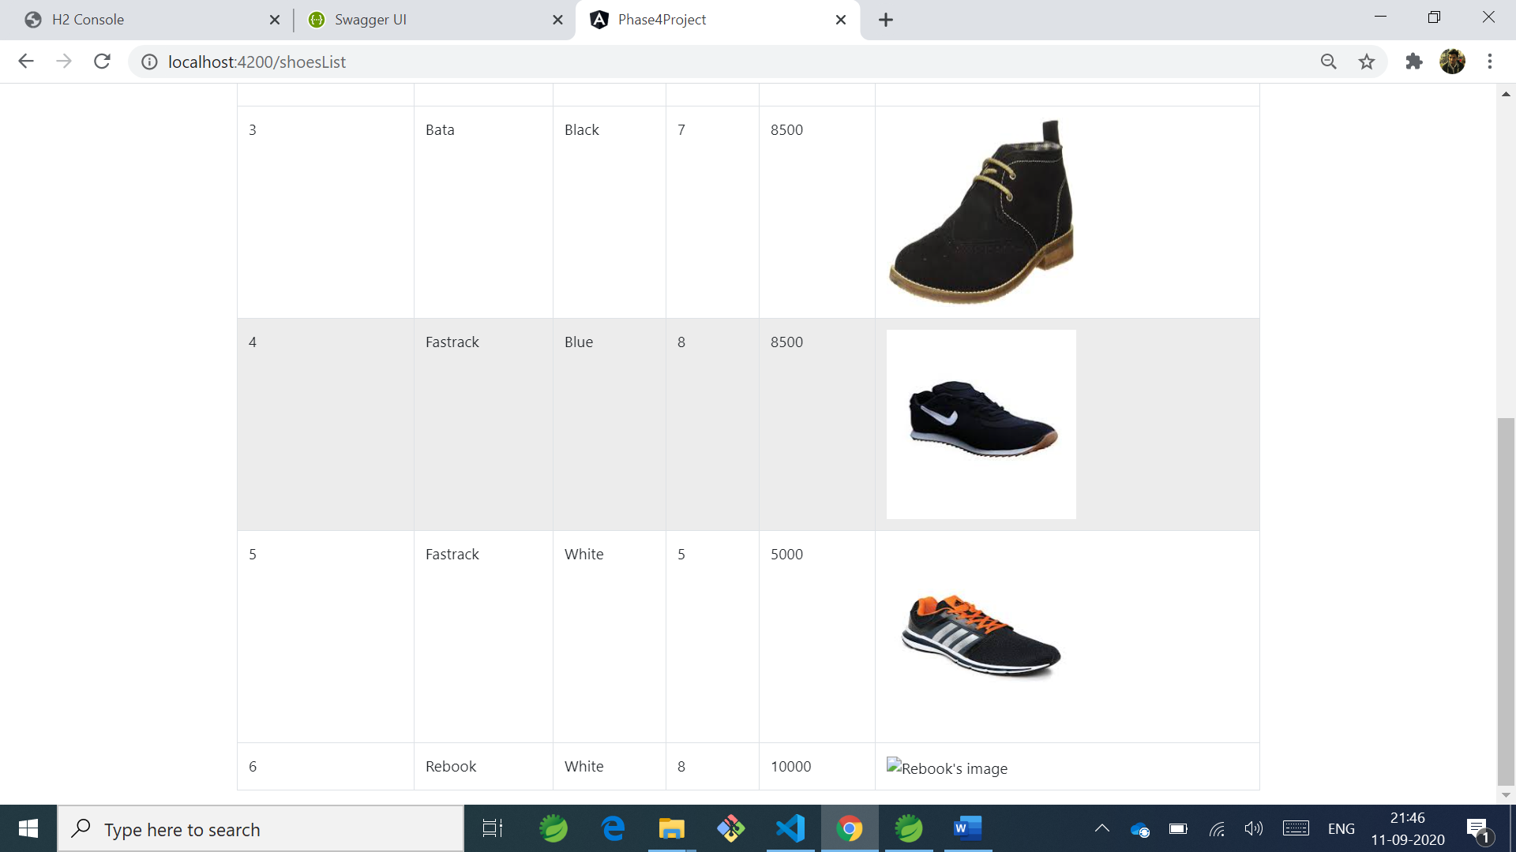

**2. Add Shoes**

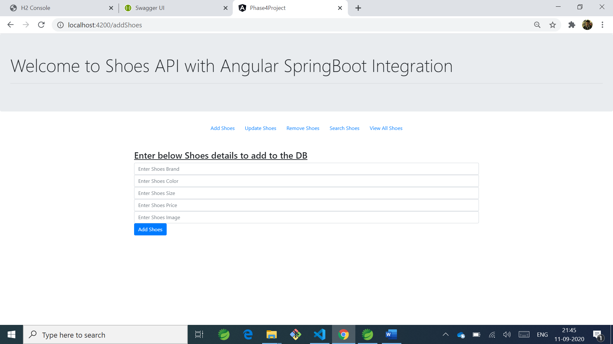

**3. Update Shoes**

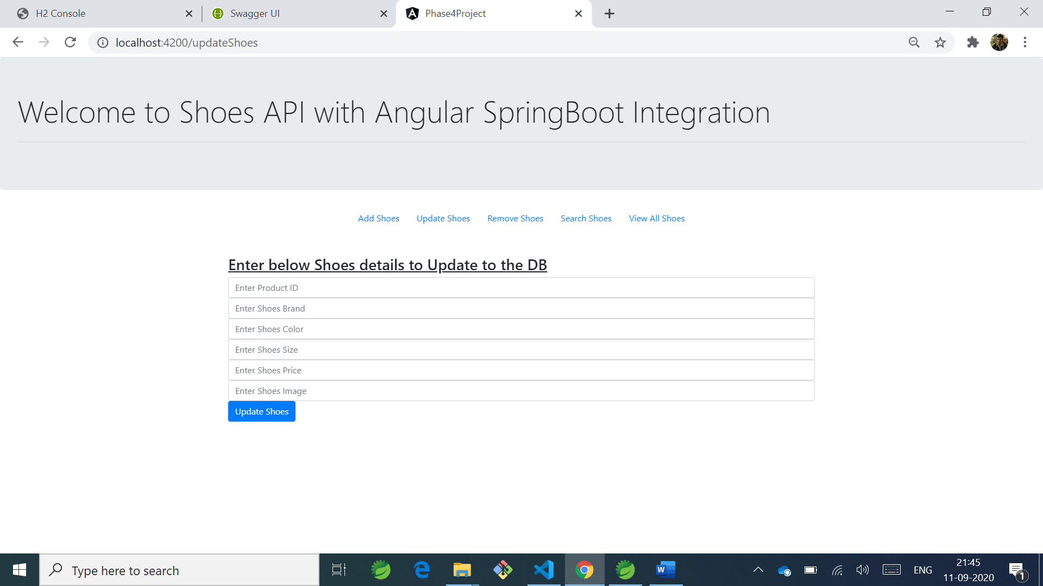

1. **Delete Shoes from Database**

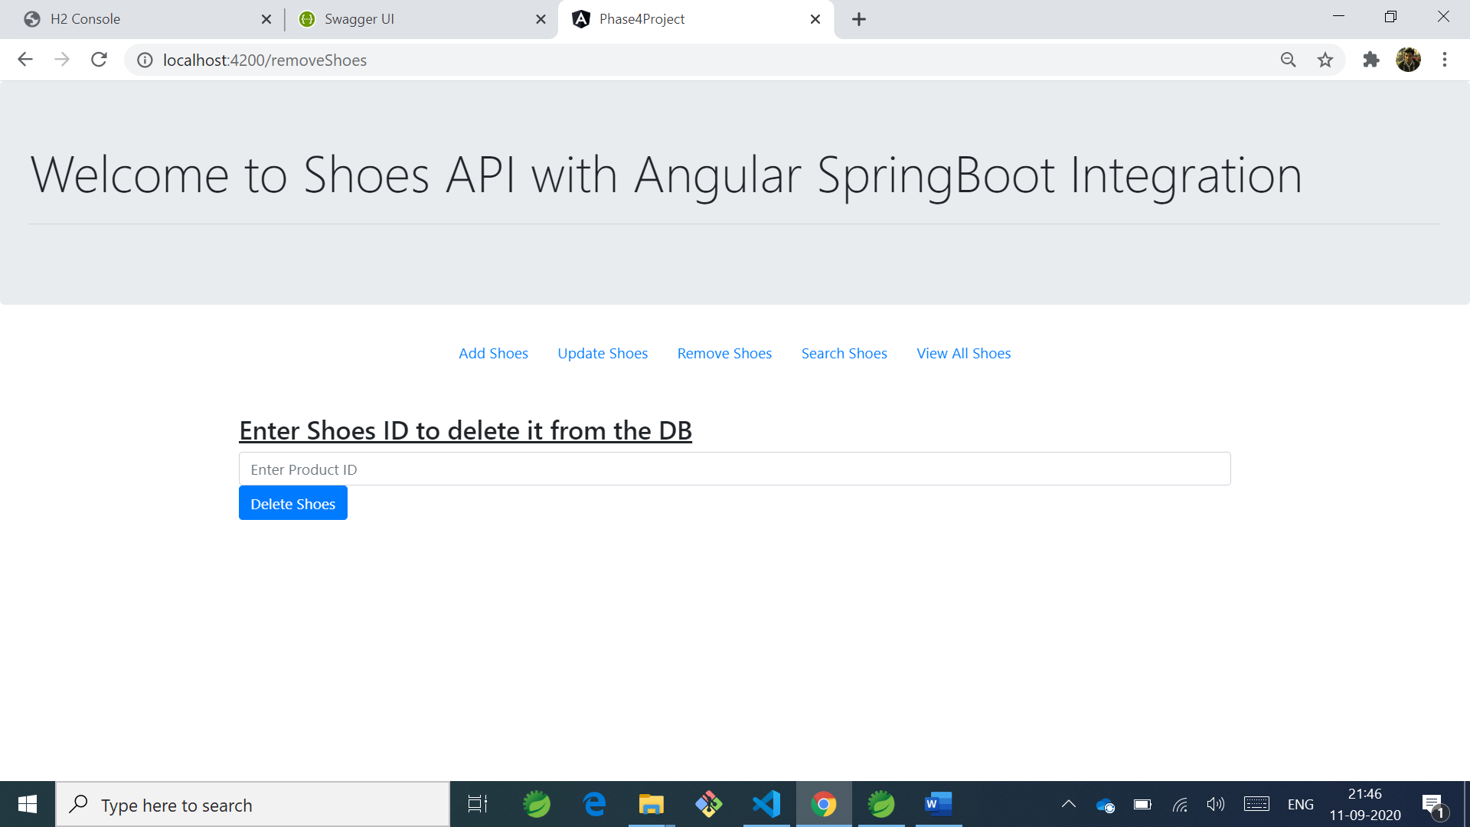

**Added 8 Shoes into Database**

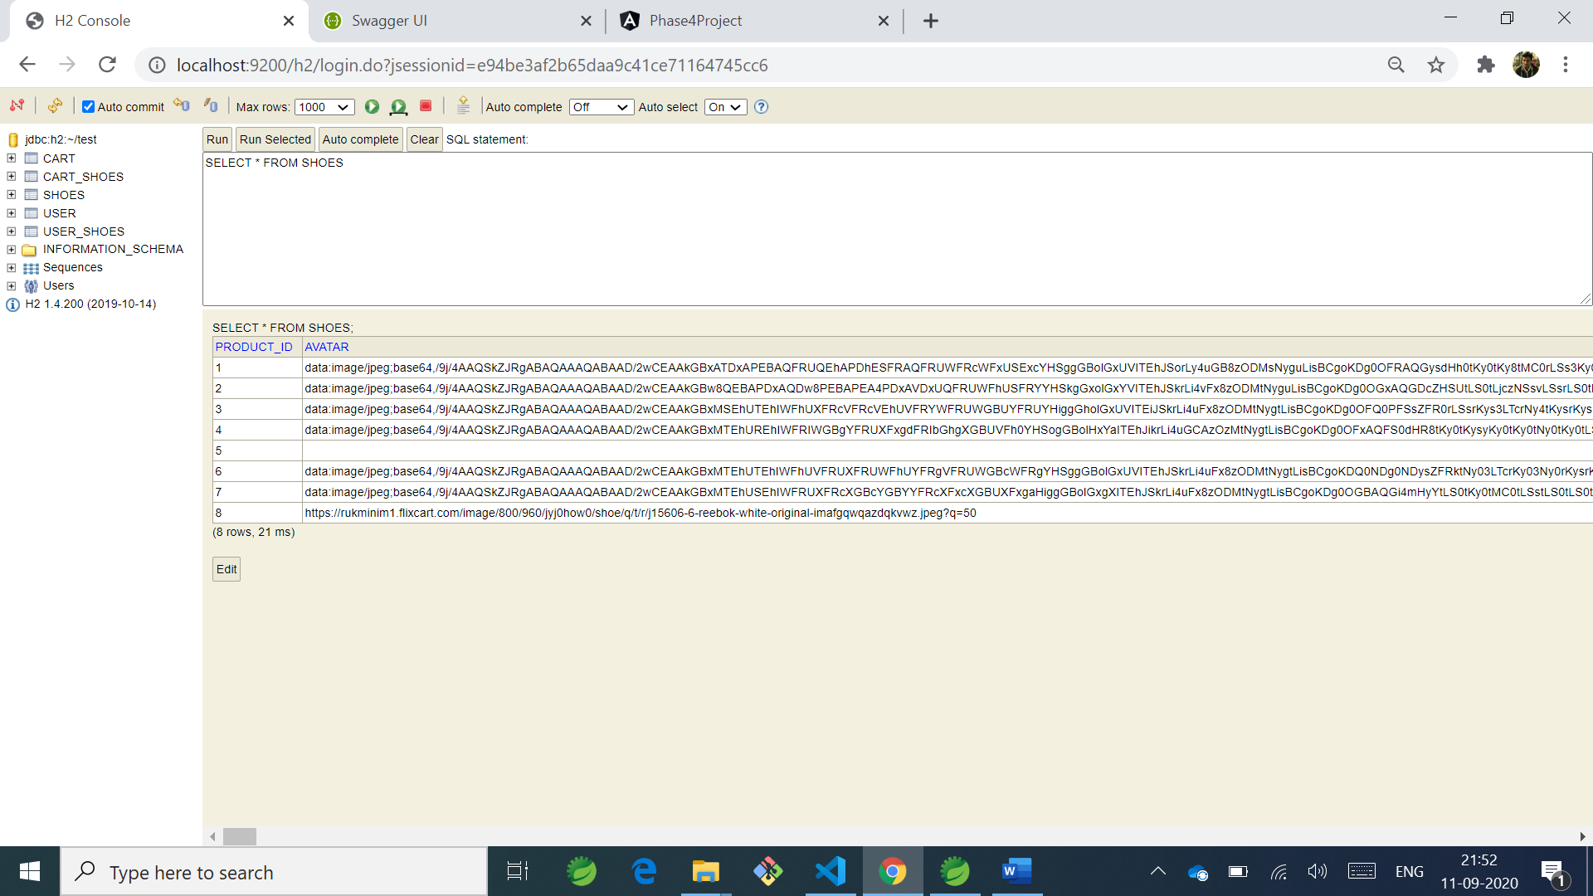

**I have implemented Swagger also,**

